
Reporting Holiday Comp Time – Full-Time Employees

There are three options for reporting time on Holidays:

- You took the holiday off.
- You worked the entire day.
- You worked part of a day.

Option 1. You took the holiday off. You do not need to report the holiday. The system automatically puts the holiday in for you. You do not need to report any time in the system.

Option 2. You worked the entire day.

If you WORKED the entire day on the holiday, you will report 8 hours of HCTES which means holiday comp time earned straight time. The system will generate 8 hours of holiday comp time for you to use at a later date but within 120 days.

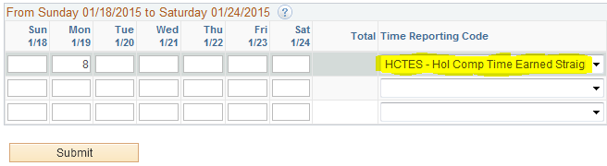

Option 3: You worked part of the day.

If you worked 2 hours on the holiday, (and took 6 hours off) you would report 2 hours of HCTES. This means you have earned two hours of holiday time to be used within 120 days. You would also add the holiday hours – 8 HOL

